**A Database Mini Project Report**

**on**

**“Pharmacy Management System”**

Submitted to the

Savitribai Phule Pune University

In partial fulfillment for the award of the Degree of

Bachelor of Engineering

In Information Technology by

**Sumit Jadhwani 33122 L9**

**Abhay Mittal 33137 L9**

**Rajas Kulkarni 33128 L9**

**Vinayak Kabra 33124 L9**

(Exam Seat No. / Roll No. & Division)

Under the guidance of

**Prof. Sumitra Jakhete**



Department Of Information Technology

Pune Institute of Computer Technology College of Engineering

Sr. No 27, Pune-Satara Road, Dhankawadi, Pune - 411 043.

**2019-2020**



**CERTIFICATE**

This is to certify that the mini project report entitled **“Pharmacy Management System”** being submitted by **Sumit Jadhwani (33122), Abhay Mittal (33137), Rajas Kulkarni (33128), Vinayak Kabra (33124) TE-9** is a record of bonafide work carried out by him/her under the supervision and guidance of Dr.Emmanuel M in partial fulfillment of the requirement for **TE (Information Technology Engineering) – 2015 course** of Savitribai Phule Pune University, Pune in the academic year 2019-2020.

Date: 15/10/2019

Place: Pune

Guide Subject Coordinator Head of the Department

Principal

This Project Based Seminar report has been examined by us as per the Savitribai Phule Pune University, Pune requirements at Pune Institute of Computer Technology, Pune – 411043 on . . . . . . . . . . .

Internal Examiner External Examiner

**ACKNOWLEDGEMENT**

Purpose of acknowledgements page is to show appreciation to those who contributed in conducting this dissertation work / other tasks and duties related to the report writing. Therefore when writing acknowledgements page you should carefully consider everyone who helped during research process and show appreciation in the order of relevance. In this regard it is suitable to show appreciation in brief manner instead of using strong emotional phrases.

In this part of your work it is normal to use personal pronouns like “I, my, me” while in the rest of the report this articulation is not recommended. Even when acknowledging family members and friends make sure of using the wording of a relatively formal register. The list of the persons you should acknowledged, includes guide (main and second), academic staff in your department, technical staff, reviewers, companies, family and friends.

You should acknowledge all sources of funding. It’s usually speciﬁc naming the person and the type of help you received. For example, an advisor who helped you conceptualize the project, someone who helped with the actual building or procedures used to complete the project, someone who helped with computer knowledge, someone who provided raw materials for the project, etc.

Sumit Jadhwani

Abhay Mittal

Rajas Kulkarni

Vinayak Kabra

(Students Name & Signature)

**CONTENTS**

|  |  |  |
| --- | --- | --- |
| **Sr.No** | **TITLE** | **Page no** |
| **1.** | **Content’s Abstract** | **5** |
| **2.** | **Introduction** | **5** |
| **3.** | **Overview** | **5** |
| **4.** | **Background and Motivation** | **6** |
| **5.** | **Methodology** | **7** |
| **6.** | **Scope** | **7** |
| **7.** | **Requirements** | **7** |
| **8.** | **E-R Diagram** | **9** |
| **9.** | **Schema Diagram** | **10** |
| **10.** | **Relational Database Design** | **11** |
| **11.** | **Database Normalization** | **13** |
| **12.** | **Graphical User Interface** | **18** |
| **13.** | **Conclusion** | **22** |
| **14** | **References** | **22** |

# 

# ABSTRACT

Nowadays, Pharmacy Management System is one of the most essential tools that are mostly used in medical stores all over the world; it is mostly used to manage pharmacy related activities such as medical inventory, record keeping, sales management and also the drug stock and expiry can be monitored.

For the implementation part, we have used **MySQL** for data storage. **HTML, CSS, Bootstrap** for front-end development, **Java Server Pages (JSP)** for connectivity & data manipulation and **AJAX** for dynamic web pages.

# INTRODUCTION

The purpose of this project is to manage all data derived for a pharmacy to maintain their business through the system rather than recording their data manually which is more risk to the business to maintain and also to avoid loss. Recording the data manually has many limitations including discrepancies of items in stock. Also it is very difficult to generate weekly/monthly report and identify business profits/loss. To overcome all these limitations, we have developed a **Pharmacy Management System - MedExpress.**

# OVERVIEW

This report discusses the result of the work done in the development of **"Pharmacy Management System** on **“JSP” Front-end Platform** and **“MySQL”** as **back-end Platform**.

At the development of an application, JSP provides a good connecting facility between all pages, also the back-end MySQL is most important to save all the data related to application.

# BACKGROUND AND MOTIVATION

The definition of our problem lies in manual system and a fully automated system.

**Manual system:** The system is very time consuming and lazy. This system is more prone toErrors and sometimes the approaches to various problems are unstructured.

**Technical system:** With the advent of latest technology if we do not update our system thenOur business results in losses gradually with time. The technical systems contains the tools of latestTrend i.e. computers printers, fax, Internet etc. The systems with this technology are very fast,Accurate, user-friendly and reliable.

# OBJECTIVE

Need of Pharmacy Management System:

1. Faster access to data such as sales reports, stock, employment details, etc.
2. Easy to use, update and maintain.
3. Easy generation and printing of bill.
4. Avoiding tedious typing task and saving time.
5. Keeps data secure.

# 

# 

# METHODOLOGY

To implement the above goals, the following methodology needs to be followed:

1. Specifying the Application and various components of the Architecture.

2. Specifying the bindings between the tasks and the resources either manually or by the design

Tools.

3. Specifying the port interconnections between the resources.

# SCOPE OF PROJECT

The scope of the project is to give a simple and user friendly application to simplify and reduce work on employees and eliminate any possibilities of human error.

Through this system we aim to not only save data about different drugs available with their existing stock and expiry date but also retrieve the same data within seconds. This system can also generate sales report so as to reduce the manual work and save hours.

# REQUIREMENTS

We are going to execute the project on windows platform. Project is compatible with all versions of Windows available after Windows Xp including it. The system should have a minimum of 512 MB of ram as well as minimum 20 GB of storage capacity. The System should also contain Apache Tomcat server and MySQL along with JDBC connector to connect server with database.

# STACK

1. MySQL - (DATABASE BACKEND)
2. JSP, AJAX, CSS, BOOTSTRAP - (FRONT END)
3. JDBC - (CONNECTIVITY)
4. Triggers/Procedures/etc

# E-R DIAGRAM

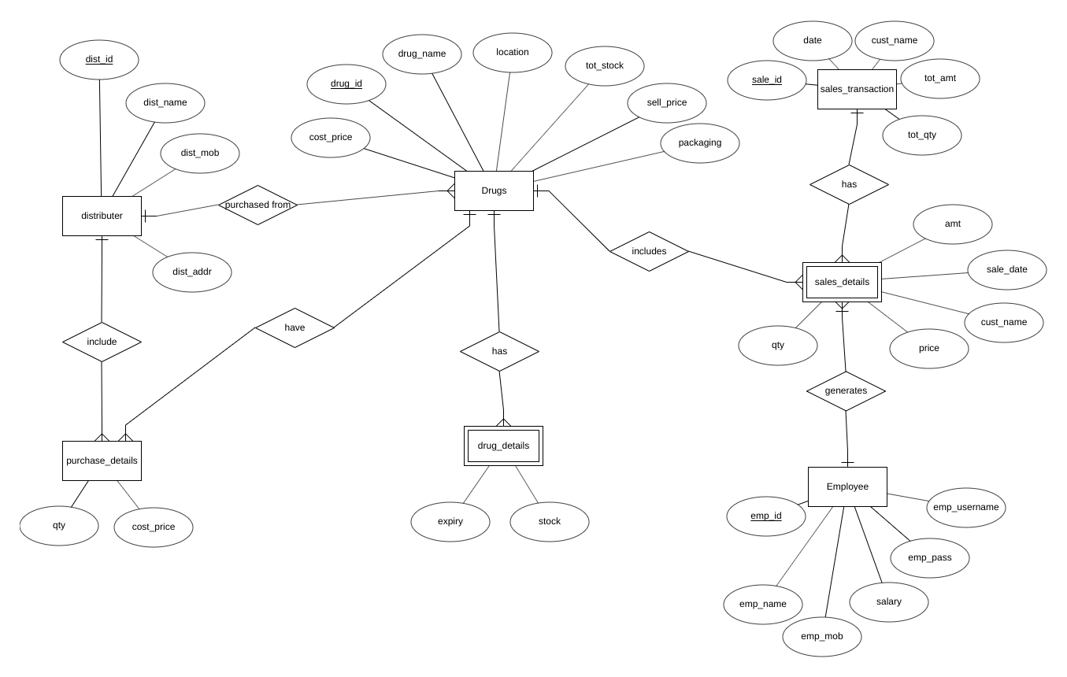

# SCHEMA DIAGRAM

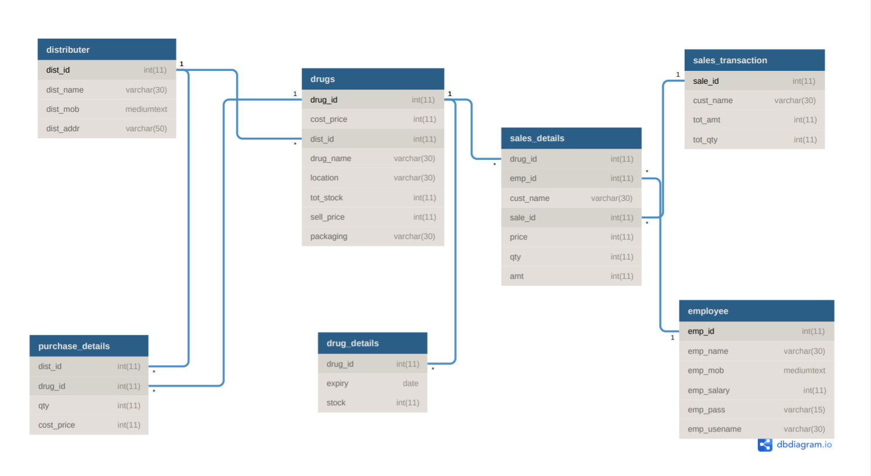

# RELATIONAL DATABASE DESIGN

**1]distributer:-**

dist_id, dist_name, dist_mob, dist_addr

|  |  |  |  |
| --- | --- | --- | --- |
| dist_id | dist_name | dist_mob | dist_addr |

**2] drugs:-**

drug_id, cost_price, dist_id, drug_name, location, stock, sell_price, packaging,expiry

|  |  |  |  |  |  |  |  |  |
| --- | --- | --- | --- | --- | --- | --- | --- | --- |
| drug_id | cost_price | dist_id | drug_name | location | stock | sell_price | packaging | expiry |

**3] employee:-**

emp_id, emp_name, emp_mob, emp_salary, emp_pass, emp_username

|  |  |  |  |  |  |
| --- | --- | --- | --- | --- | --- |
| emp_id | emp_name | emp_mob | emp_salary | emp_pass | emp_username |

**4] purchase_details:-**

dist_id, drug_id, qty, cost_price

|  |  |  |  |
| --- | --- | --- | --- |
| product id | drug_id | qty | cost_price |

**5] sales_details:-**

drug_id, emp_id, cust_name, sale_id, sale_date, price, qty, amt

|  |  |  |  |  |  |  |
| --- | --- | --- | --- | --- | --- | --- |
| drug_id | emp_id | cust_name | sale_id | sale_date | qty | amt |

**6] sales_transaction:-**

sale_id, emp_id, cust_name, sale_id, tot_amt, tot_qty

|  |  |  |  |  |  |
| --- | --- | --- | --- | --- | --- |
| sale_id | emp_id | cust_name | sale_id | tot_amt | tot_qty |

# DATABASE NORMALIZATION:

## FIRST NORMAL FORM

The relation is in 1NF if it has no repeating groups. All tables have no repeating groups so they are in 1NF.

### TABLES:-

**1]distributer:-**

|  |  |  |  |
| --- | --- | --- | --- |
| dist_id | dist_name | dist_mob | dist_addr |

**2] drugs:-**

|  |  |  |  |  |  |  |  |  |
| --- | --- | --- | --- | --- | --- | --- | --- | --- |
| drug_id | cost_price | dist_id | drug_name | location | stock | sell_price | packaging | expiry |

**3] employee:-**

|  |  |  |  |  |  |
| --- | --- | --- | --- | --- | --- |
| emp_id | emp_name | emp_mob | emp_salary | emp_pass | emp_username |

**4] purchase_details:-**

|  |  |  |  |
| --- | --- | --- | --- |
| product id | drug_id | qty | cost_price |

**5] sales_details:-**

|  |  |  |  |  |  |  |
| --- | --- | --- | --- | --- | --- | --- |
| drug_id | emp_id | cust_name | sale_id | sale_date | qty | amt |

**6] sales_transaction:-**

|  |  |  |  |  |  |
| --- | --- | --- | --- | --- | --- |
| sale_id | emp_id | cust_name | sale_id | tot_amt | tot_qty |

## 

## SECOND NORMAL FORM

A relation is said to be in second normal form if it is already in first normal form and it has no partial dependency

**1)**    **distributer:**

The absence of partial dependency in relation takes it into 2NF without any modification

**2)**    **drugs:**

Drugs table is breakdown into two table due to partial dependency in between drug and expiry. So another table (drug_details) is created having drug_id as foreign key and expiry and stock as other attributes.

|  |  |  |
| --- | --- | --- |
| drug_id | expiry | stock |

**3)**    **employee:-**

The absence of partial dependency in relation takes it into 2NF without any modification

**4)**    **purchase_details:-**

The absence of partial dependency in relation takes it into 2NF without any modification

**5)**    **sales_details:-**

The absence of partial dependency in relation takes it into 2NF without any modification

**6)**    **sales_transaction:-**

The absence of partial dependency in relation takes it into 2NF without any modification

### TABLES:-

**1]distributer:-**

|  |  |  |  |
| --- | --- | --- | --- |
| dist_id | dist_name | dist_mob | dist_addr |

**2] drugs:-**

drugs

|  |  |  |  |  |  |  |  |
| --- | --- | --- | --- | --- | --- | --- | --- |
| drug_id | cost_price | dist_id | drug_name | location | tot_stock | sell_price | packaging |

drug_details

|  |  |  |
| --- | --- | --- |
| drug_id | expiry | stock |

**3] employee:-**

|  |  |  |  |  |  |
| --- | --- | --- | --- | --- | --- |
| emp_id | emp_name | emp_mob | emp_salary | emp_pass | emp_username |

**4] purchase_details:-**

|  |  |  |  |
| --- | --- | --- | --- |
| product id | drug_id | qty | cost_price |

**5] sales_details:-**

|  |  |  |  |  |  |  |
| --- | --- | --- | --- | --- | --- | --- |
| drug_id | emp_id | cust_name | sale_id | sale_date | qty | amt |

**6] sales_transaction:-**

|  |  |  |  |  |  |
| --- | --- | --- | --- | --- | --- |
| sale_id | emp_id | cust_name | sale_id | tot_amt | tot_qty |

## THIRD NORMAL FORM

A relation is said to be in third normal form if it is already in 1st and 2nd NF and has no transitive dependency.

**1)**    **distributer:**

The absence of partial dependency in relation takes it into 2NF without any modification

**2)**    **drugs:**

Drugs table is breakdown into two table due to partial dependency in between drug and expiry. So another table (drug_details) is created having drug_id as foreign key and expiry and stock as other attributes.

|  |  |  |
| --- | --- | --- |
| drug_id | expiry | stock |

**3)**    **employee:-**

The absence of partial dependency in relation takes it into 2NF without any modification

**4)**    **purchase_details:-**

The absence of partial dependency in relation takes it into 2NF without any modification

**5)**    **sales_details:-**

The absence of partial dependency in relation takes it into 2NF without any modification

**6)**    **sales_transaction:-**

The absence of partial dependency in relation takes it into 2NF without any modification

### TABLES:-

**1] distributer:-**

|  |  |  |  |
| --- | --- | --- | --- |
| dist_id | dist_name | dist_mob | dist_addr |

**2] drugs:-**

|  |  |  |  |  |  |  |  |
| --- | --- | --- | --- | --- | --- | --- | --- |
| drug_id | cost_price | dist_id | drug_name | location | tot_stock | sell_price | packaging |

drug_details

|  |  |  |
| --- | --- | --- |
| drug_id | expiry | stock |

**3] employee:-**

|  |  |  |  |  |  |
| --- | --- | --- | --- | --- | --- |
| emp_id | emp_name | emp_mob | emp_salary | emp_pass | emp_username |

**4] purchase_details:-**

|  |  |  |  |
| --- | --- | --- | --- |
| product id | drug_id | qty | cost_price |

**5] sales_details:-**

|  |  |  |  |  |  |  |
| --- | --- | --- | --- | --- | --- | --- |
| drug_id | emp_id | cust_name | sale_id | sale_date | qty | amt |

**6] sales_transaction:-**

|  |  |  |  |  |  |
| --- | --- | --- | --- | --- | --- |
| sale_id | emp_id | cust_name | sale_id | tot_amt | tot_qty |

# GRAPHICAL USER INTERFACE

The application is user friendly with a simple GUI interface implemented in HTML, CSS, BOOTSTRAP and for dynamic pages JSP and AJAX. All features are self - explanatory. Add, Delete, Update, Display are available to perform the intended action. Also forms include placeholders to give description of particular input fields.

# FEATURES

1. Clean separation of various components to facilitate easy modification and revision.
2. All the data is maintained in a separate file to facilitate easy modification
3. All the data required for different operations is kept in a separate file.
4. Quick and easy saving and loading of database file.

# SNAPSHOTS OF THE APPLICATION

## EMPLOYEE VIEW

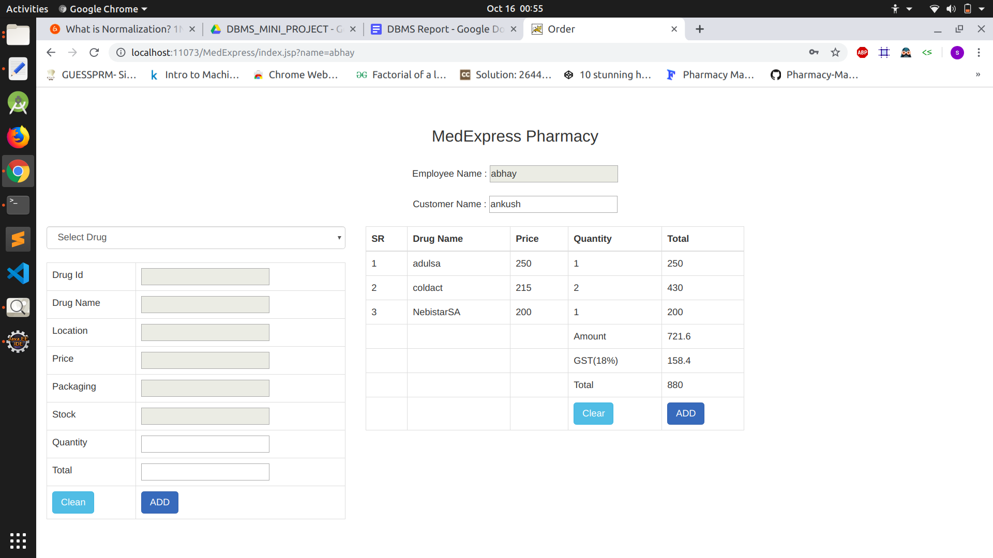

## 

## EMPLOYEE VIEW

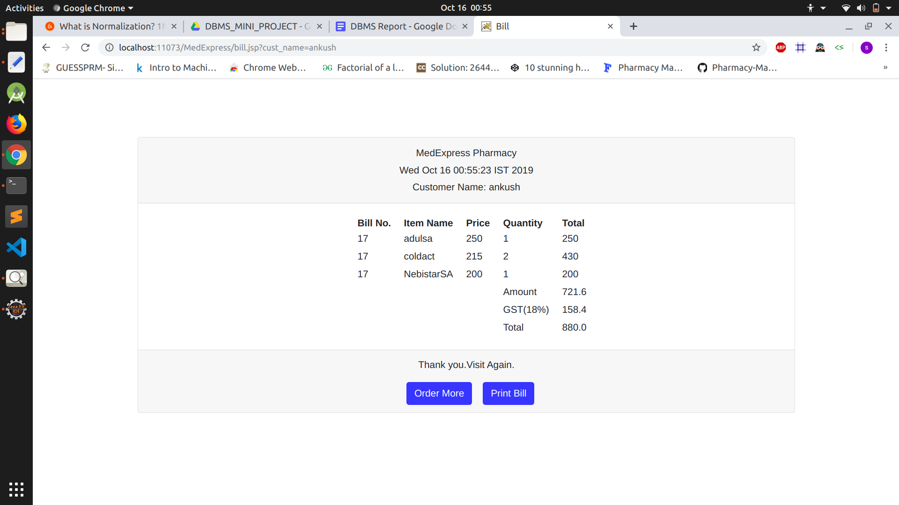

## 

## ADMIN VIEW

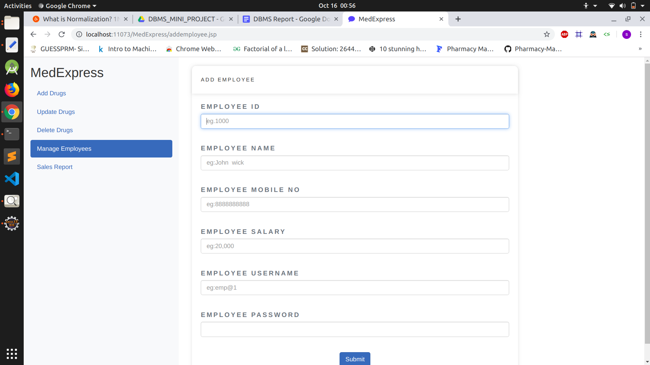

## ADMIN VIEW

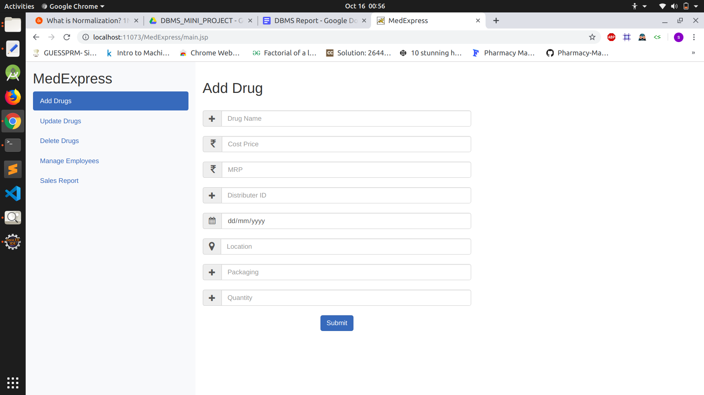

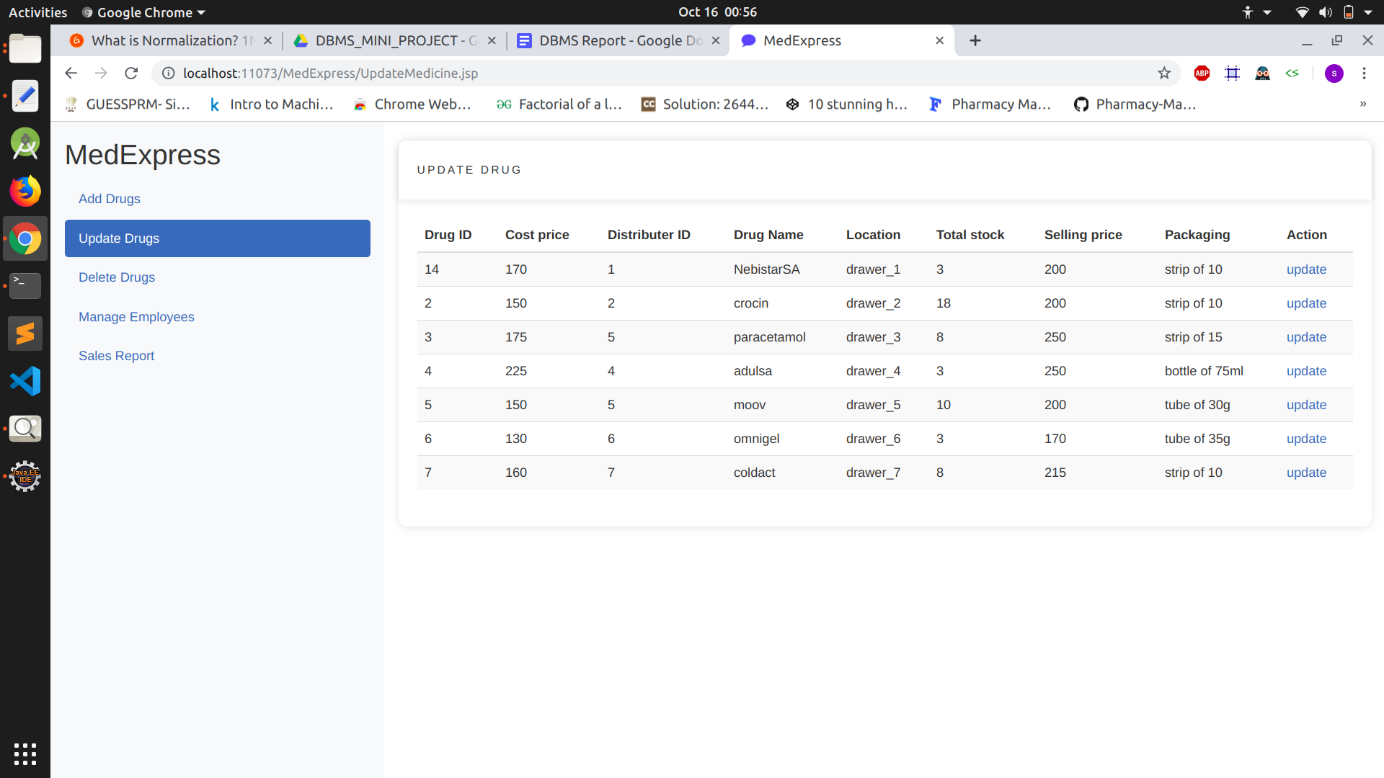

# CONCLUSION

Thus we have successfully implemented Pharmacy Management System which helps us to manage all the data which is generated in a Medical Store. By implementing this assignment, we’ve understood the core concepts of database management system (MySQL).

# SOFTWARE USED

1. Eclipse Enterprise Edition IDE.
2. Web Browser.

# REFERENCES

1. Javatpoint
2. W3schools
3. Database Management Systems By Johannes Gehrke
4. Ajax - The complete reference by Thomas Powell